Dr. Sunday F. Zechariah,
Director of Clinicals,
Heritage Kidney and Medical Care,
Plot 1528 B11 Kaura District,
FCT-Abuja.
5th October, 2026.
The Chief Executive Officer,
Heritage Kidney and Medical Care,
Plot 1528 B11 Kaura District,
FCT-Abuja.

Cc:
Mrs. Joy O. Emeh,
Human Resource Manager,
Heritage Kidney and Medical Care.

Dear Sir,
REQUEST FOR TWO DAYS ABSENCE FROM WORK
I hereby write to respectfully request for permission to be absent from work for two days which includes, Monday, 5th October and Tuesday, 6th October 2026. This is to enable me to attend to some urgent matters that need my attention.
I sincerely regret any inconvenience my absence may cause. However, I have made provisions to ensure that all duties that will need my attention will be adequately covered.
Thank you for your understanding.
Yours faithfully,
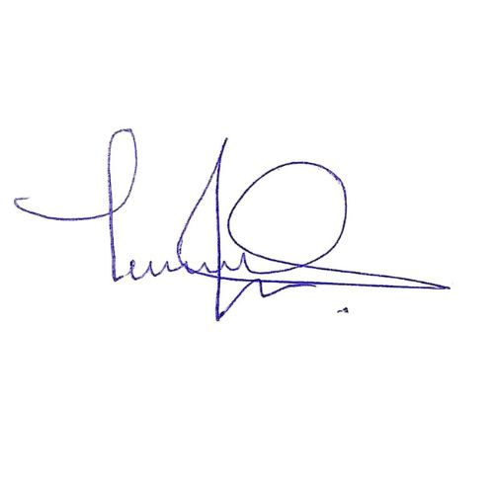
….……………………
Dr. Sunday F. Zechariah
Director of Clinicals
Heritage Kidney and Medical Care (HKMC)

